Linux File Permissions
Dan Richter
11 Sep 2020

If you are just trying out Linux for the first time, and came from a Windows background, there is one thing that will trip you up. File permissions…

First of all, in Linux, keep in mind that everything, including directories are considered files. This isn’t a major issue, but something to keep in mind.

Also, as Linux is a multi user operating system, meaning multiple people can have log in privileges on a computer, and each of them will have their own /home directory. Now, if you have someone else able to log into your computer, you may not want them to be able to see the files that you have in your home directory. Linux handles this very well with file permissions, but it does take a bit to understand it completely.

Let’s go over some terminology before we delve deeper into permissions.

User

A user is the owner of the file. If you create a file, Linux will assign your user as the owner.

Group

Each user is assigned to a group. If you are on a single user system, this group name might be the same as your user name. With groups, you can assign specific people to these groups, and give them access to files based on these groups.

Other

Other is pretty much as it sounds. They are not the ones who created the file, and therefore do not own it, or part of the group that has access to this file. Usually, at least in my case, Other will fall under someone connecting to your computer via the network, and logged in autonomously.

Does that make sense? Clear as mud, right? Well, let’s add a few more terms before we get into the explanations.

Permissions

Read

This permission gives the user the right to read the file/directory. They will be able to list the files/contents, and open files within the directories.

Write

This permission will give the user the authority to write to these files, or add files. They are able to ‘write’ to the directories.

Execute

This one can really get some people when coming from Windows. In Windows, you know a file is executable, as it has the .exe extension. In Linux, any file can be executable, and the extensions of the file do not matter, nor are they required. Each file can be assigned the ‘executable’ flag, so they are able to be ‘run’.

Ok, now that you are probably completely confused, we’ll try to clear it up a bit.

Go to your terminal, and ‘cd’ into a directory in your /home, that contains some files. Once there, type in ‘ls -l’ and hit enter. This will bring up a list of the contents of the directory, but also gives us some more information about the files.

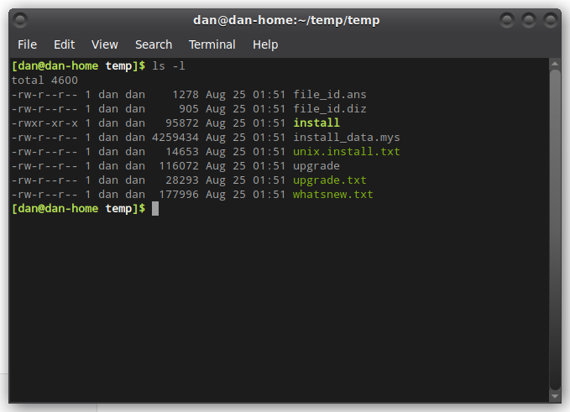
In this example, you can see the list of files on the right, along with the date, time, and size of the files. It’s the information on the left that we will be looking at. If you see the first file, file_id.ans, it shows:
‘-rw-r--r--’. What the heck does that mean? Let’s look at it a bit differently, so it makes sense to you. I’ll just take this list and move it vertically, like this:

-
r
w
-
r
-
-
r
-
-

I’ll do this again, but will have an explanation of what each one is, or could be.

- If this were a directory, this character would show as a ‘d’. As this is a file, it shows as a ‘-’
r You, being the user with access, have ‘read’ access to this file
w You, being the user with access, have ‘write’ access to this file
- If this file were executable, this character would be an ‘x’
r Members of your group, in my case ‘dan’, have ‘read’ access to this file
- Members of your group, do not have ‘write’ access to this file
- Members of you group, do not have access to ‘execute’ this file
r Other users, not in group, have ‘read’ access to this file
- Other users do not have ‘write’ access to this file
- Other users do not have ‘execute’ access to this file

Now, if you look again at the screenshot above, take a close look at the file named install. The permissions are a little different than the others. That file has ‘execute’ access by everyone, user, group, and others.

I hope that helped make things a little clearer. When looking at the list on the screen from using ‘ls -l’, just remember the first character shows a ‘d’ if it’s a directory. The next three characters show permissions for the user. The next three are for the group, and the last three are for others.
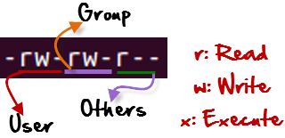
One more quick note, on the screenshot of the list of files run by ‘ls -l’, it will also show who the user (owner) of the file is, and which group they belong to. In those examples, my user name is ‘dan’, and the group name is also ‘dan’. If I were to go into the /var directory, which is managed by the operating system you will see different names.

In the following screenshot, you can see the files are owned by ‘root’. You will also notice that most of these are directories, as they are indicated by the ‘d’ in the first field. There is also a few of them that indicate ‘l’ in the first field. Those are actually something we haven’t talked about yet, but they are called Symbolic Links. They are basically a shortcut to another file or directory.

You will also notice that they list ‘others’ as having read access. In this case, as these files are owned by ‘root’, we are considered others. We are also not part of the groups listed for these files.
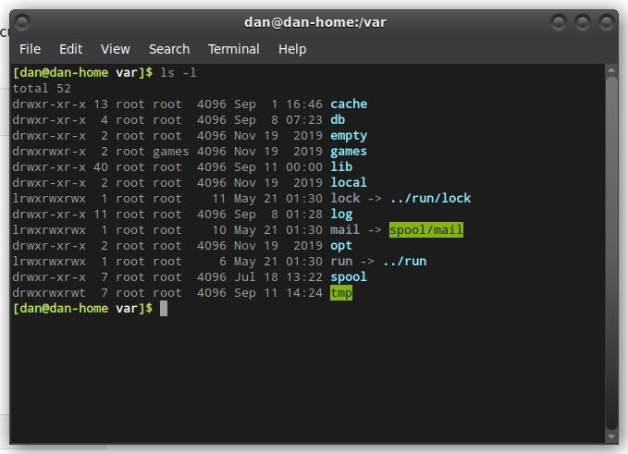

So, now that you are an expert at reading the permissions, how can we change them? There are a couple different ways to do this. First is with your file manager, and the other is through the terminal.

From your file manager, you will be able to ‘right click’ on a file, and then select ‘Properties’. You will then have a window pop up containing information about that file.

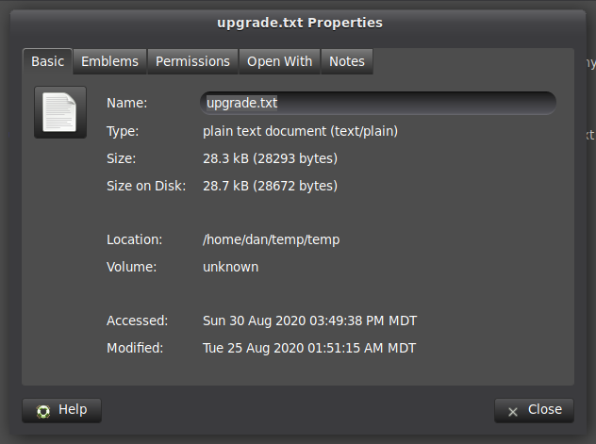

As you can see, there are tabs at the top of the window. If you click on ‘Permissions’, it will give you all the permissions setting for that file.

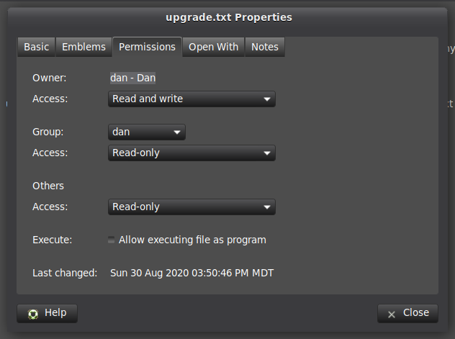
From this screen, you can see the permission setting for a particular file or directory. You can also change it using the drop down menus. Also, if you click the box by ‘Execute’, you can make this file executable.

Keep in mind, this is the way things look using Mate and Caja for a file manager. Each desktop environment will have their own file manager, which may look a little different, but the options should be the same or similar.

While working in the terminal, which I actually do quite a bit, you can accomplish the same thing, but it takes a little more understanding of what is actually happening when you change the permissions.

chmod permissions filename

This is the command we’ll be using from the terminal to change the permissions. There are two ways that changes can be made with this command. One is ‘Absolute(Numeric) Mode’ and the other is ‘Symbolic Mode’. We’ll start with Absolute(Numberic), as I think this gives a better understanding of what is happening.

The first thing we need to know, is the numbers associated with the permissions and how they work. The following table will give you a brief understanding of them:

Number | Permission Type | Symbol
0 | No Permission | ---
1 | Execute | --x
2 | Write | -w-
3 | Execute + Write | -wx
4 | Read | r--
5 | Read + Execute | r-x
6 | Read + Write | rw-
7 | Read + Write + Execute | rwx

Now, if we have a particular file, let’s use the upgrade.txt file from earlier. Right now, the permissions are as follows:

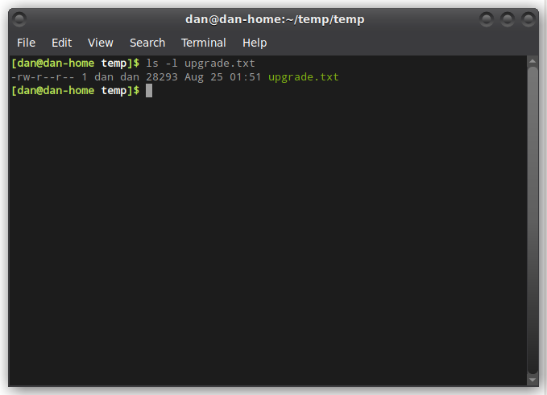
Right now, the owner, dan, has both read and write permissions, while the group and others only have read access to the file. First, let’s give everyone access to write to that file.

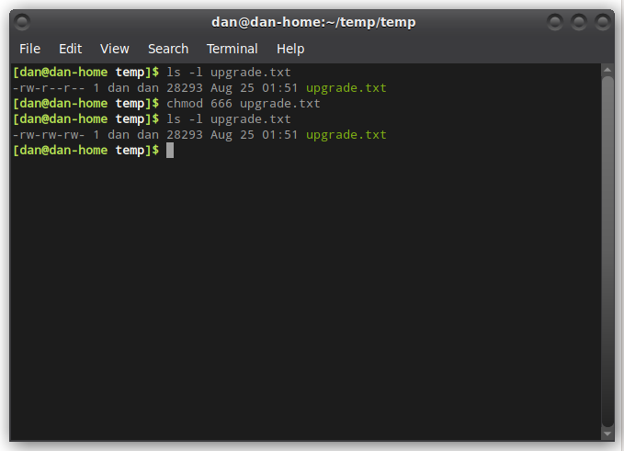
Now if we look at the permissions, the user, group and others all have read and write access to this file. Once we know that everyone is finished writing to that file, we can change the permissions again. Let’s put them back how they were previously.

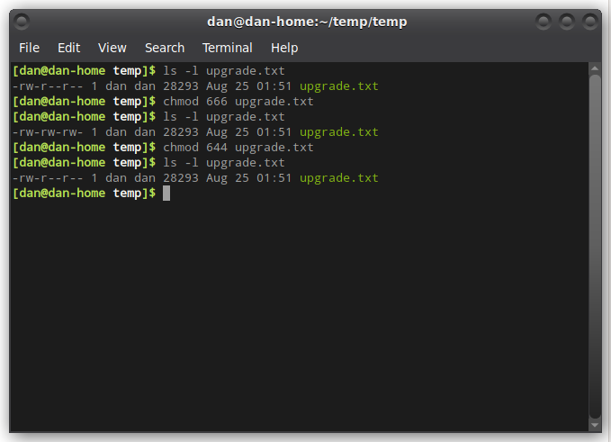
There, now the permissions are set back to only allow the group and others to read the file.

Symbolic Mode

Symbolic mode is a little different, as you don’t need to know the numerical representations, but there are some other things you need to know. There are three different operators that are used, along with indicating the different users.

Operator | Description
+ | Adds a permission to a file or directory
- | Removes the permission
= | Sets the permissions and overrides the permissions set earlier

User Denotations
u | user/owner
g | group
o | other
a | all

So, now let’s do the same thing we did earlier, and give everyone access to write to the file upgrade.txt. We will then change the permissions back to just allow the user to write, but let everyone else read the file.

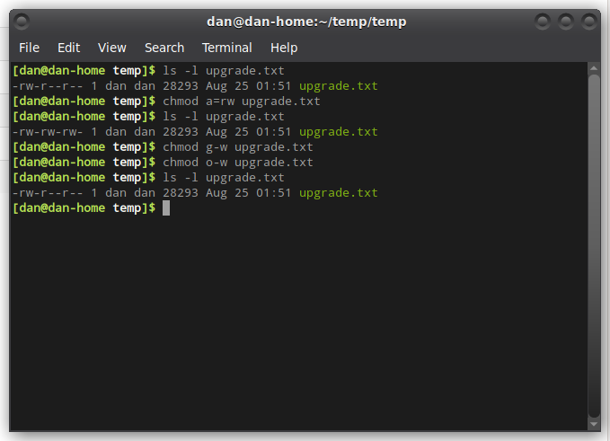
In the first ‘chmod’ line, I added ‘rw’ which is read and write, to ‘a’ all users. Then, to remove the write access, I sent the ‘g-w’ and ‘o-w’ commands. These remove the ‘w’ write access from both ‘g’ group and ‘o’ others.

